Mechanical Engineering

Vibration Analysis Problem Set

Team:

Plan B

Team Leader:

Austin Dionne

Team Members:

Austin Dionne, Greg Hovagim, Carlos Lazo, Nate Soule

Course: TDC1 – Mechanical Engineering: Vibration Analysis

Instructor: David Vaillette

Date Submitted: 04/13/09

Problem # 1 – Analysis of the Circuit Card

1) Using MathCAD 14.0 and mechanical engineering formulas, we concluded the following:

Board Dimensions
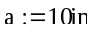
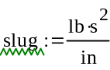
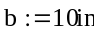
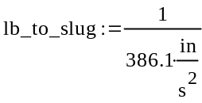
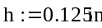
Board Weight
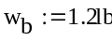
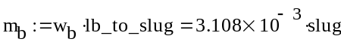
Board Mass
Modulus of Elasticity
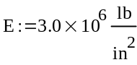
Poisson's Ratio
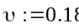
Mass per Unit Area
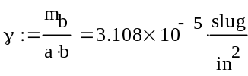

Frequency Parameter
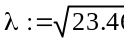
Natural Frequency
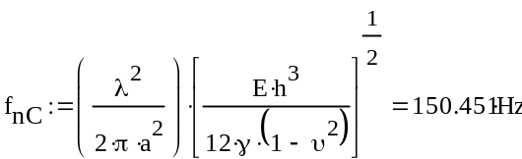
Frequency Parameter
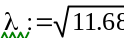
Natural Frequency
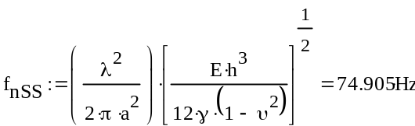
Therefore, the predicted natural frequency is:
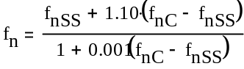
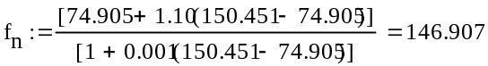
Hz

Case < 100 Hz, Clamped:

Case > 600 Hz, Simply Supported:

Confirming clamped and simply supported frequencies with frequency.xls:

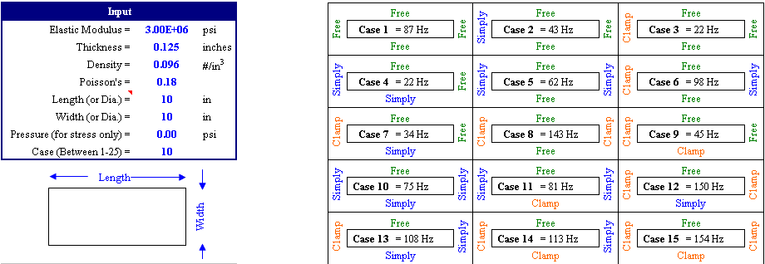

Confirming combined predicted frequency with wedge_lok.xls:

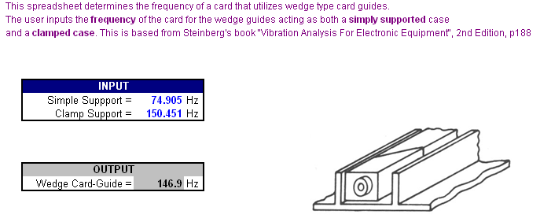

2) Using MathCAD 14.0 and mechanical engineering formulas, we concluded the following:

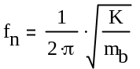
We rearrange the equation to solve for stiffness variable K.
We know that our predicted natural frequency = 146.907 Hz.

Plugging into our equations, we get the following answer:
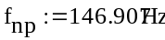
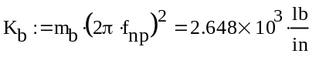

3) Using MathCAD 14.0 and mechanical engineering formulas, we concluded the following:

Transmissibility
In our problem, we assume that the transmissibility can be described by the following equation:

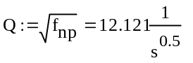
Therefore, our maximum displacement results in:

Since transmissibility is a unitless variable, we eliminate the units:
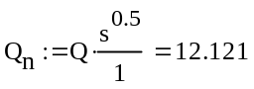

Peak Input -
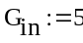

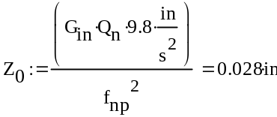

4) In looking at our given figure, we compute the following allowable displacement of our system based on the physical constraints of the card cage:

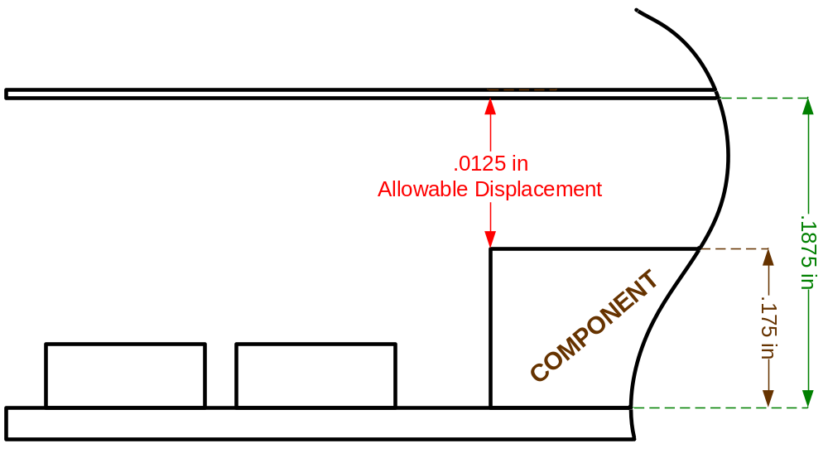
Since our maximum displacement, 0.028’’ is > the allowable displacement, 0.0125’’:

The component will hit the adjacent wall during sine vibration.

In order to decrease the maximum displacement during sine vibration testing, the predicted natural frequency of the system would need to be increased. One feasible way of doing this would be to add ribbing to the PCB (printed circuit board).

Ribbing would be placed along the entire length of the PCB. The number of ribs, the height of the ribs, and the way they are connected to the board would all play a factor into the end natural frequency of the PCB. The ribs should be lightweight, so as to not add too much more weight to the board itself. The following graphs gives an example of the sorts of gains one would expect from adding 1-3 ribs on a 8x12in board.

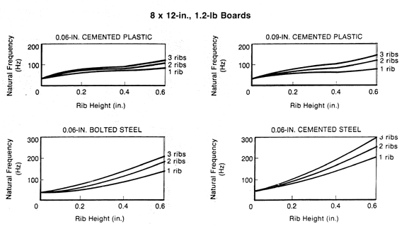

Using these types of curves and knowing that the ribs cannot be any higher than the height of the tallest component, one could determine which rib configuration to choose, given that there is sufficient space between components.

Problem # 2 – Shock Analysis of the Circuit Card

1) The following is a picture of the 90 G, 5 ms half sine shock pulse:

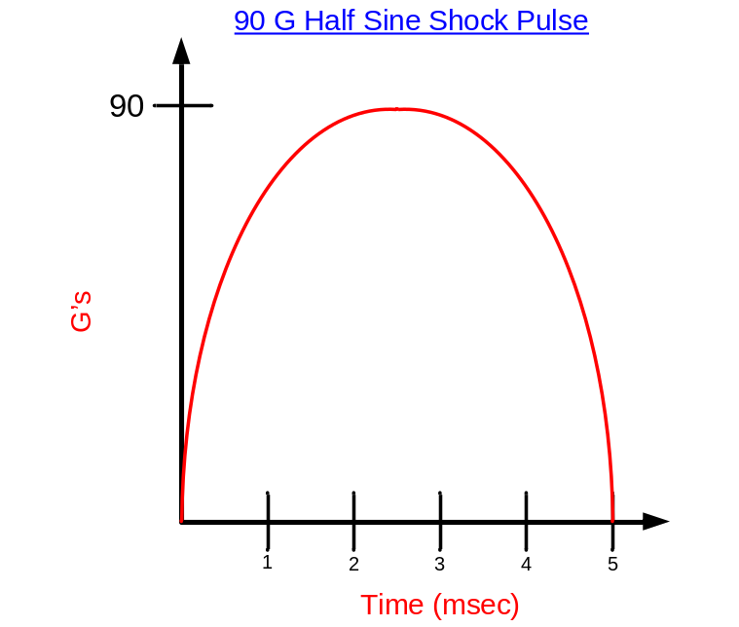

We calculate our fn * t first in order to determine the DLF of the system, assuming that we are using 146.907 Hz as the natural frequency of our system:

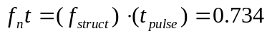

From analyzing the DLF curves provided, we determined that our DLF is:

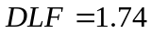

This can also be confirmed by using DLF(shock).xls, as seen below:

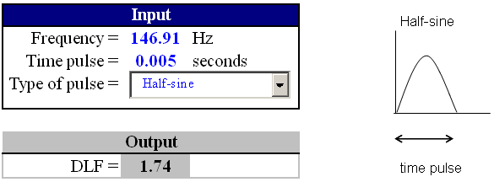

We compute our desired frequency using the formula below:

G = 90
DLF = 1.74
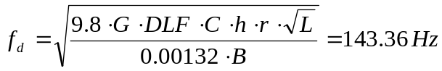C = 1
h = .125
r = 1
L = 2
B = 10

This can be confirmed by using Avip-E.xls, as seen below:

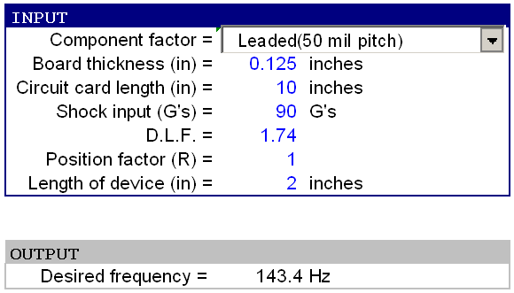

Since our desired frequency, 143.36 Hz < the system’s natural frequency of 146.907 Hz:

The circuit will be capable of satisfactory operation in such an environment.

2) The actual and desirable component deflections were found using the following equations:


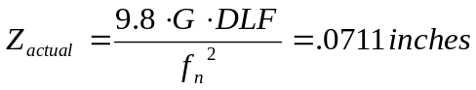
G = 90
DLF = 1.74
C = 1
h = .125
r = 1
L = 2
B = 10
f_{n} = 146.907

Based on the calculations shown above, it can be seen that:

The desirable displacement of the board is greater than the actual displacement seen.

3) Both required calculations are determined using the formulas below:



t = .005
G = 90
g = 386.1
C = 1, NR
= 2, FR

Problem # 3 – Random Vibration Analysis of the Circuit Card

1) The 1σ G_{RMS} value is determined through the following calculations:

Slope 1: 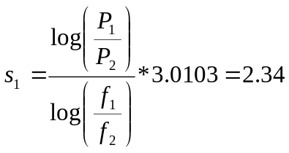

Slope 2: 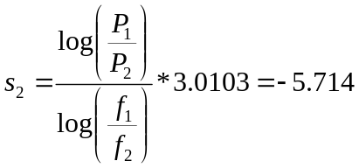

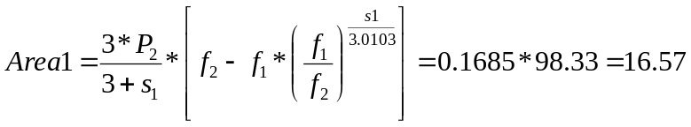

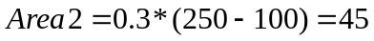

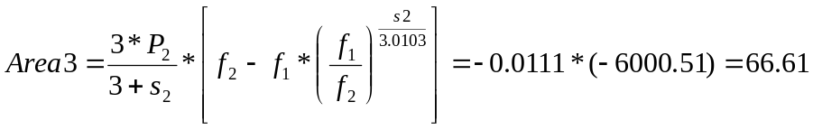

We find 1σ G_{RMS} by taking the square root of the sum of the three areas of our PSD curve:

This can be verified using two-degree-of-freedon.xls, as seen below:

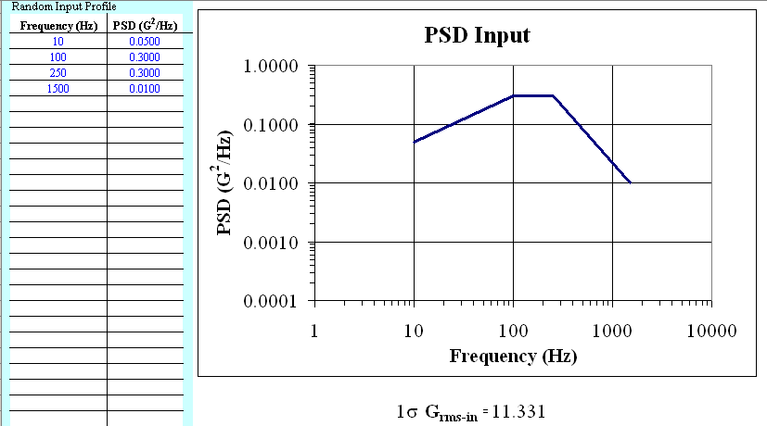

2) To find the 3σ displacement, simply multiply the 1σ displacement by a factor of 3:

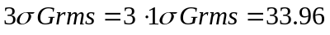

Use the following equation to compute the 3σ peak displacement of the board:

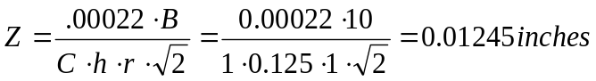

3) A sinusoidal vibration is a single frequency vibration that changes uniformly over time. A random vibration is a dynamic combination of frequencies interlaced to create its own upper and lower frequency limits changing non-uniformly in time. Overall, random vibration is a more accurate model to the actual operating environment than sinusoidal vibration. The unpredictability factor of random vibration provides a great amount of insight versus the sweep technique of sinusoidal vibration.
Problem # 4 – Acoustic Analysis of the Chassis Cover

1) The one-third octave bandwidth of the center frequency is found using the equations below:

Board Dimensions 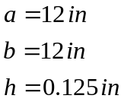

Board Density 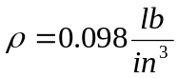

Modulus of Elasticity 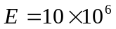

Poisson’s Ratio 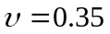

Mass per Unit Area 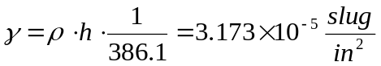

Frequency Parameter 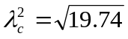 (from Blevins Table 11-4)

Natural Frequency 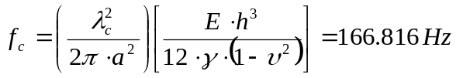

One-Third-Octave

2) The sound pressure spectral density is found using the equation below:

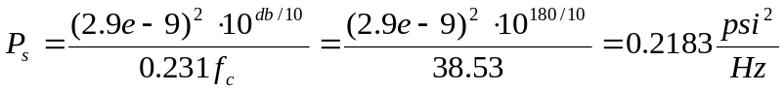

3) The equivalent pressure seen on the CC surface is found using the equation below:

4) Using the Frequency.xls spreadsheet and given all our parameters, the respective stress and deflection values can be found. Assuming that all sides are simply supported, we are interested in analyzing Case 16:

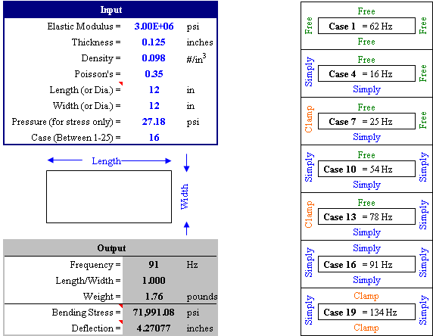

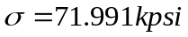
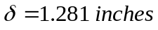

5) Since there is currently 1.281 inches of deflection, stiffening the chassis is a necessity. This can be done by adding ribs to the cover. The center frequency of the system will go up, which will in turn reduce the sound pressure spectral density. A reduction in sound pressure spectral density will reduce the equivalent pressure that will be seen on the circuit card surface, which will reduce the overall deflection seen on the chassis cover.

